On Jun 28, 2018, at 9:41 PM, Environmental Management (EMVM) <[em@editorialmanager.com](mailto:em@editorialmanager.com)> wrote:  
>   
> CC: [em_eic@baylor.edu](mailto:em_eic@baylor.edu), [jacob_stanley@baylor.edu](mailto:jacob_stanley@baylor.edu)  
>   
> Dear Professor Paudel,  
>   
> We have received peer reviews of your manuscript entitled "Adoption of Sustainable Agriculture Practices among Kentucky Farmers", which was submitted to Environmental Management. Based on these reviews, your manuscript could be reconsidered for publication should you be prepared to incorporate major revisions.    
>   
> When preparing your revised manuscript, you are asked to carefully consider the reviewer comments that are attached, and submit a list of responses to these comments, indicating the page and line numbers of each comment. If you disagree with any specific reviewer comment, provide a justification for your decision to not make these changes.  All changes in the revised manuscript must be highlighted in Word to assist checking of revisions by the editorial staff. Please make sure to submit your manuscript as editable source files (i.e. Word, TeX).    
>   
> Please also submit your responses to the reviewers' comments as a separate submission item.  
>   
> In addition, all papers need an acknowledgment section that gives information on all financial and in-kind support for the project.   
>   
> In order to submit your revised manuscript, please access the Editorial Manager system.  
>   
> Your username is: paudekp  
>   
> If you forgot your password, you can click the 'Send Login Details' link on the EM Login page at [Link Deleted]  
>   
> We look forward to receiving your revised manuscript by 28 Aug 2018.  
>   
> With kind regards,  
> Environmental Management Office  
> Environmental Management  
>   
> Comments for the Author(s):  
> Editorial comments: The title of the article should insert ", USA" after "Kentucky" in the revised submission.   
> Addressed. New Title: **Adoption of Sustainable Agriculture Practices among Kentucky, USA Farmers.**  
> Reviewer #1:   
> The paper studies one of the oldest problem in the field of agricultural studies: the adoption of new practices by farmers. It has been studied in particular during the green revolution in order to understand how innovation are diffusing, and since then in many different studies concerning the adoption of so called sustainable practices by farmers. The originality of the paper does not lie on the theme, but on the survey that has been applied to support the authors’ conclusions. This survey is impressive and its results are correctly analyzed. Some findings are interesting (particularly the fact that agricultural innovation are localized), even if not surprising.   
> Nevertheless, I found three major problems with this paper:  
>   
> First, the bibliography review gives the impression that the study of agricultural innovation diffusion only started in the last few years. It is far from true, of course, and there are many different approaches of such a problem: **I think in particular that spatial studies should have been taken into account to explain one of the major finding of the paper (see below).**

I am not very clear what the bolded part just above is trying to say. The initial part of the paragraph talks about timeline of agriculture innovation diffusion, which I can address stating since when this talk has begun and how it has been developed since then. To address spatial studies, should I add more literature on similar researches from different parts of the world? Or any alternative?

Answer: We tried to take an account of spatial factor in the paper. However, USDA/NASS data policy did not allow us to go to the smaller level than the Agriculture District. We tried to run the analysis

Furthermore, studies that make links between innovation and public policies, or farm development, are not really used in the bibliography review, which explains that there is not any independent variable that uses policy factors, access to agricultural extension webs, etc. Even if the survey cannot be done again included such factors, they must be taken into account in the discussion to underlie the limits of the study.

> My understanding about this comment: Add that policy factor’s role in the adoption of SAPs has not been studied (except Tobacco Buyout Program) in this research in the DISCUSSION section of paper with proper justification.

> Second, the discussion makes assertions that are not demonstrated, nor by statistical analysis neither by field studies (doing interviews with farmers for instance). For instance, when authors try to explain why districts have different incident rate of adopting SAPs, their explanations can be contradicted by other bibliographical studies (p. 18, l. 38 to 48: large cities use to influence positively the adoption of sustainable practices) or be contradictory with assertions made in the same papers (the conclusion p. 19, l. 29-39 are opposite to those of p. 18).  
>   
> Last, all SAP innovation are considered as having the same importance in the paper while they don't have the same impact. **I suggest that authors make a distinction between innovation, and studying particularly those that are more important for sustainable agriculture.**

> One way is, I mentioned that practices included in this paper are commonly adopted technologies by farmers. SAPs could be several if we take into account of all. What is the best alternative to address this comment in other way?

Also, I found a thesis from University of Kentucky studying SAP adoption related to water quality. The research has found that the variable or combination of variables that are significant are unique for unique practice. So, it is not possible to summarize combination of 31 practices by single equation, though this research adds important knowledge in current situation, as there is virtually no research in Kentucky in this issue.

How about addressing this comment in this way?  
>   
>   
> Reviewer #2: This piece is a timely study on the determinants of the adoption of more sustainable agricultural practices in Kentucky. The study clearly has relevance, and the authors do a fine analysis. Below are some more detailed considerations, but in a nutshell I believe further revision is needed primarily to better contextualize the research and present the results in a way that highlight their novelty value a bit more.  
>   
> The Introduction currently is a bit black-and-white and it black-boxes what is labeled as "Sustainable Agriculture Practices". Techniques such as conservation tillage or "cover crops" are mentioned without ever being explained. I think this needs to be fleshed out; you can't assume all readers know the details and characteristics of these practices you cite. Moreover, some of these techniques have pros and cons. No-till agriculture, for instance, usually means an increase in the use of herbicides. So clearly it is not black-and-white as sometimes presented. It is a matter of nuancing what the authors are saying and giving a bit more detail while cutting on the repetition. If a point is made, you don't need to carry on repeating it.  
> Should I put a table of SAPs that I included in the paper with their short definitions to address this comment? I already have this in my thesis. I may need to revise some references that I included in my thesis.

> The beginning spends perhaps too long lauding the merits of Sustainable Agriculture Practices without ever going in much depth about them. It becomes repetitive without being too informative. This can be easily redressed by cutting back on the "laudation" of the importance and benefits of sustainability in agriculture (which can really take no more than a paragraph or two, as it is a pretty consensual point) and devote more space to fleshing out the problems of (1) unsustainable agriculture to date and (2) of explaining, as illustrative examples, particular techniques you deem important and characteristic of sustainable agriculture in the Kentucky context. Some better contextualization ought to be given, particularly for readers who may not be too familiar with the Kentucky context. (Some of these techniques do get talked about from p.11 on, but they should be mentioned early, not just in the results section. By then the readers should already know what you are talking about  
> when referring to SAPs)  
> should I cut texts from the beginning without reducing message I am trying to convey from the literature review? Also, any particular suggestions regarding page 11 comments? My understanding is, reviewer want to me summarize some literature about SAPs in KY context.

> The section "Literature Review" could receive a more attractive title. More importantly, it would greatly benefit from a summarizing table. The authors cite a number of studies that seem to point to the relevance of multiple factors, but it is challenging for the reader to keep track of all those. A table, containing the various factors as well as the references to the studies that discuss them, should not be too hard to put together and would substantially increase the usefulness of this section. It would also add value to the lit review work you have done.

> I think commenter wants me to include something like this (below) summarizing literature review.

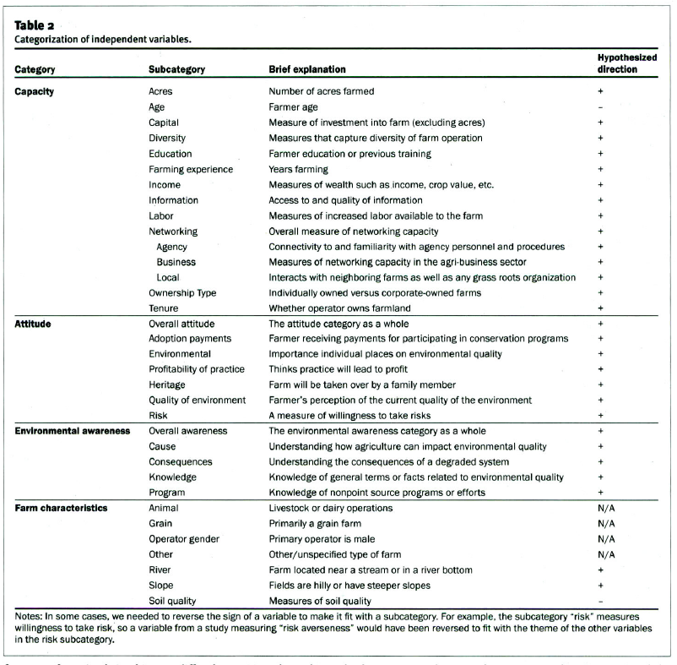

> The sections 3 and 4 could also receive better titles that aren't just bare and basic as "Conceptual Framework". Moreover, this may be a misnomer. The authors do not really discuss or set *concepts* in there. I think this section belongs much better merged with what currently is 4, as a "Methodology" section.  
>

> The authors should highlight a bit better the relevance of Kentucky as a traditional farming state also within the broader USA context, not just within the state per se. It would also be very useful to get a bit more context; currently the authors hardly even give us the background of farming in Kentucky or what the farmers there grow and the relevance of that for the state economy, for livelihoods, etc.  
> 

> In section 5, it would be extremely useful to have a synthesis of the findings on a table or figure. The authors discuss many variables in sequence. A synthesis at the end of the section would be really handy.  
> I am not sure what this means? Reviewer wants a table with what is the result: positive, negative, significant and not significant? (I already have one there). Or, should I put same result that I narrate in the body in the tabulated form as well?

> The authors should be much more objective in their Conclusions section. Right now there is too much recap, and restatement of general considerations that everyone already knows (e.g. farmers make decisions on the basis of multiple factors). Instead, the authors should state their conclusions more objectively and emphasizing the novelty value of their research findings on top of what was already known from the literature.   
>

> A few more specific remarks below:  
>   
> P.5  
> L.46: "Age is found to have a negative effect". Be specific. If you mean that older farmers are less likely to change their practices, say it explicitly.  
> L.47: "THE education" sounds odd if you are not referring to specific type of education but just to schooling in general.

Addressed:

Older farmers are less likely to adopt new practices which they are not very familiar with (Awan et al. 2015; Baumgart-Getz et al. 2012; Kabii and Horwitz, 2006). But, farmers are positive and more likely to adopt sustainable agriculture practices as they achieve higher level of formal education (Soule, 2001; Upadhyayet al*.* 2003).

> P.8  
> L.41: The motivation behind adoption of SAPs cannot be presented as "either/or". Surely there are farmers who adopt SAPs *both* due to environmental considerations and economic expectations.

Addressed:

Also there are farmers who adopt SAPs considering economic and environmental benefits.